**DAILY ONLINE ACTIVITIES SUMMARY**

|  |  |  |  |  |  |  |  |  |
| --- | --- | --- | --- | --- | --- | --- | --- | --- |
| **Date:** | **05-06-2020** | | | | | **Name:** | **Deeksha D Poojary** | |
| **Sem & Sec** | **VIII Semester & A Section** | | | | | **USN:** | **4AL16CS026** | |
| **Online Test Summary** | | | | | | | | |
| **Subject** | | **BDA** | | | | | | |
| **Max. Marks** | | **16** | | **Score** | | | **30** | |
| **Certification Course Summary** | | | | | | | | |
| **Course** | **Introduction to Hadoop & Robotic Process Automation** | | | | | | | |
| **Certificate Provider** | | | **Great Learning & Ui Path** | | **Duration** | | | **4 Hours & 3 Hours** |
| **Coding Challenges** | | | | | | | | |
| **Problem Statement: Program to create inverted half pyramid.** | | | | | | | | |
| **Status: COMPLETED** | | | | | | | | |
| **Uploaded the report in Github** | | | | | **YES** | | | |
| **If yes Repository name** | | | | | **Deekshapoojari** | | | |
| **Uploaded the report in slack** | | | | | **YES** | | | |

Online Test Details:

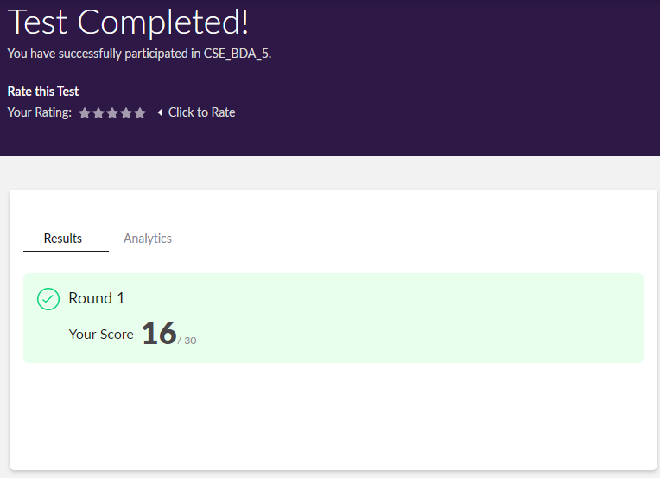

Certification Course Details:

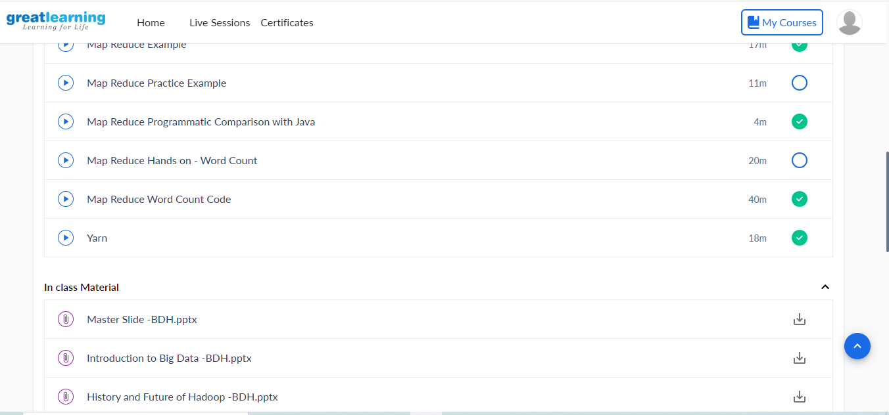

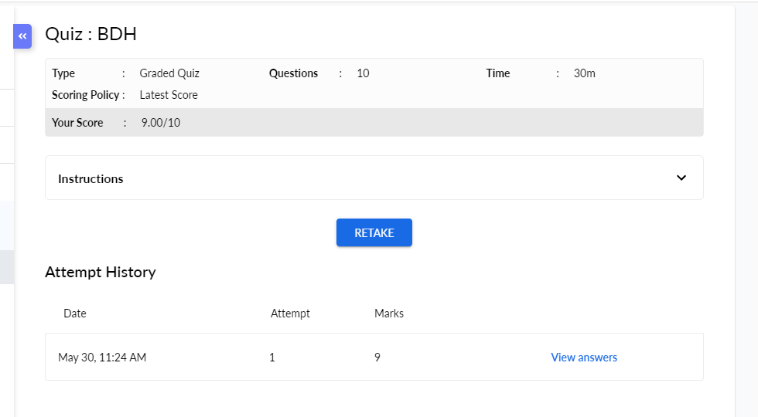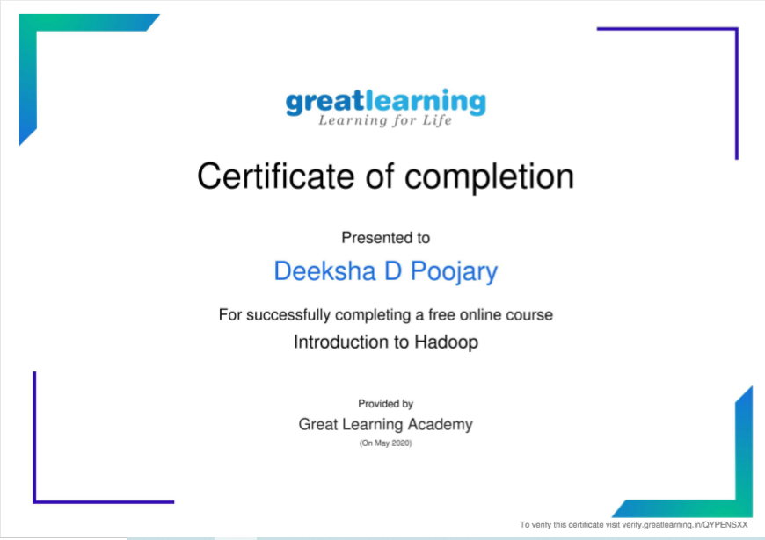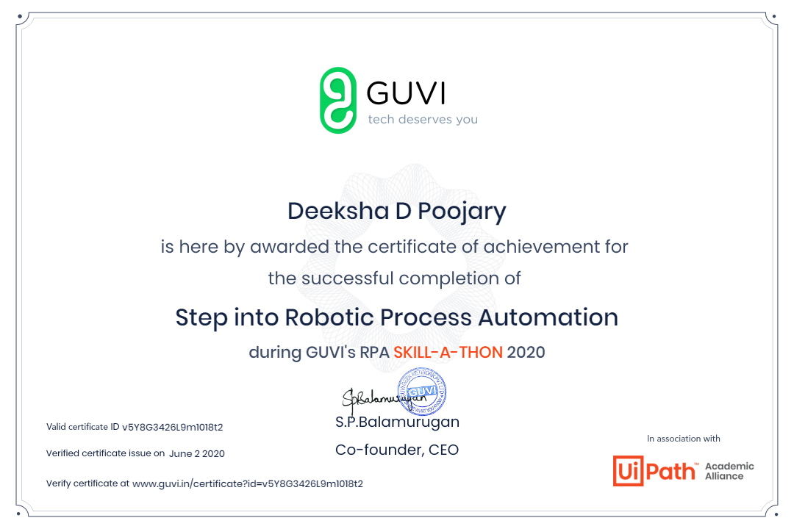

Coding Challenges Details:

|  |
| --- |
|  |
|  |
|  |
|  |
|  |
|  |
|  |
|  |
|  |
|  |
|  |
|  |
|  |
|  |
|  |
|  |
|  |
|  |
|  |
|  |
|  |
|  |
|  |
|  |
|  |
|  |
|  |
|  |
|  |
|  |
|  |
|  |
|  |
|  |
|  |
|  |
|  |
|  |
|  |
|  |
|  |
|  |
|  |
|  |
|  |
|  |
|  |
|  |
|  |
|  |
|  |
|  |
|  |
|  |

**Program1:**

**#include <stdio.h>**

**int main() {**

**int i, j, rows;**

**printf("Enter the number of rows: ");**

**scanf("%d", &rows);**

**for (i = rows; i >= 1; --i) {**

**for (j = 1; j <= i; ++j) {**

**printf("* ");**

**}**

**printf("\n");**

**}**

**return 0;**

**}**